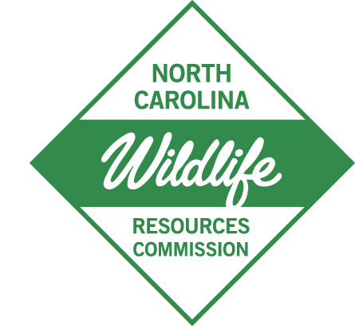

August 12, 2025

**M E M O R A N D U M**

TO: Interested Parties

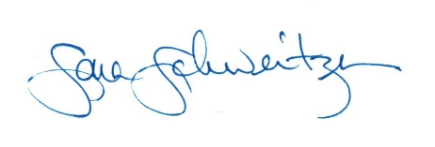

FROM: Sara Schweitzer, Nongame Wildlife Advisory Committee Liaison

NC Wildlife Resources Commission

SUBJECT: Notice of Official Meeting

***Thursday, August 28, 2025, at 10:00 a.m.***

Raleigh, North Carolina

Pursuant to G.S. 143-318.13, the North Carolina Wildlife Resources Commission, a public body of the State of North Carolina, hereby files notice of a meeting of the **Nongame Wildlife Advisory Committee**. This official meeting will be held in the Commission Conference Room, 5th Floor, 1751 Varsity Drive, Raleigh, NC.

**Thursday, August 28, 2025,** at 10:00 a.m. – 2:30 p.m.

Members of the public may join in person or via Zoom by clicking on the link below to register:

<https://ncwildlife-org.zoomgov.com/webinar/register/WN_uHHtWg9AS4KISmF3KgIz7g>