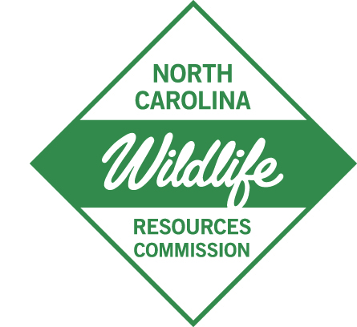

November 10, 2025

M E M O R A N D U M

TO: Interested Parties
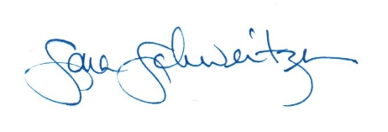
FROM: Sara Schweitzer, Nongame Wildlife Advisory Committee Liaison
NC Wildlife Resources Commission

SUBJECT: Notice of Official Meeting
Thursday, November 13, 2025, at 10:00 a.m.
Raleigh, North Carolina

Pursuant to G.S. 143-318.13, the North Carolina Wildlife Resources Commission, a public body of the State of North Carolina, hereby files notice of a meeting of the Nongame Wildlife Advisory Committee. This official meeting will be held in the Commission Conference Room, 5th Floor, 1751 Varsity Drive, Raleigh, NC.

Thursday, November 13, 2025, at 10:00 a.m. – 1:30 p.m.

Members of the public may join in person or via Zoom by clicking on the link below to register:

https://ncwildlife-org.zoomgov.com/webinar/register/WN_BolpfsNNQ_mqSnCGb8-Ntw

